CONCURRENT COLLECTIONS – COMPLETE DEEP DIVE (FINAL NOTES)
(Hierarchy · Thread-safe vs Concurrent · Use cases · All classes · Real-time examples · Step-by-step)

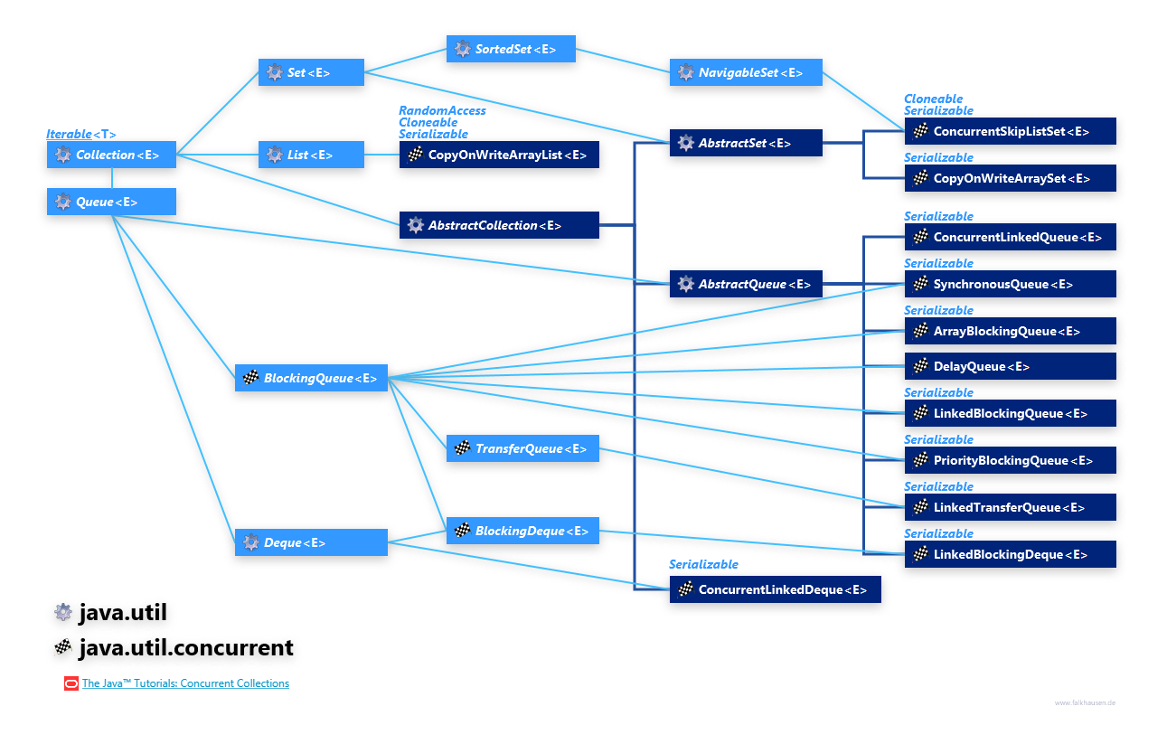
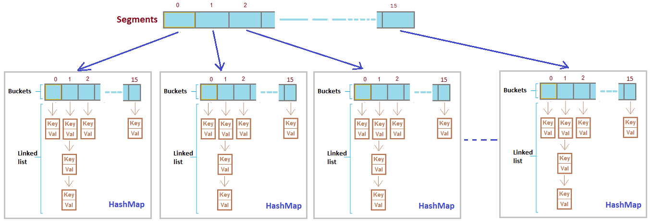

OUNDATION: What “Concurrency” Means
- Multiple threads access the same collection at the same time
- Problems without concurrency support
  - Data inconsistency
  - ConcurrentModificationException
  - Race conditions
- Two approaches exist
  - Thread-safe (synchronized, single lock, slow)
  - Concurrent (fine-grained locking or lock-free, fast)

Why Concurrent Collections Exist
- Traditional collections are not safe in multi-threaded environments
- Synchronized collections provide safety but poor performance
- Concurrent collections provide thread safety with high concurrency
- Used in real enterprise and production systems

Thread-Safe vs Concurrent (VERY IMPORTANT)
Thread-Safe Collections
- Use single lock (synchronization)
- One thread accesses collection at a time
- Low performance under high concurrency
- Example: Vector, Hashtable, Collections.synchronizedList()
Concurrent Collections
- Use fine-grained locking / lock-free algorithms
- Multiple threads can read/write simultaneously
- High performance and scalability
- Example: ConcurrentHashMap, CopyOnWriteArrayList
Interview line
Thread-safe ensures safety, concurrent ensures safety with performance
LIST IN JAVA – TYPES, NON-CONCURRENT vs CONCURRENT (DEEP, STEP-BY-STEP WITH REAL-TIME EXAMPLES)

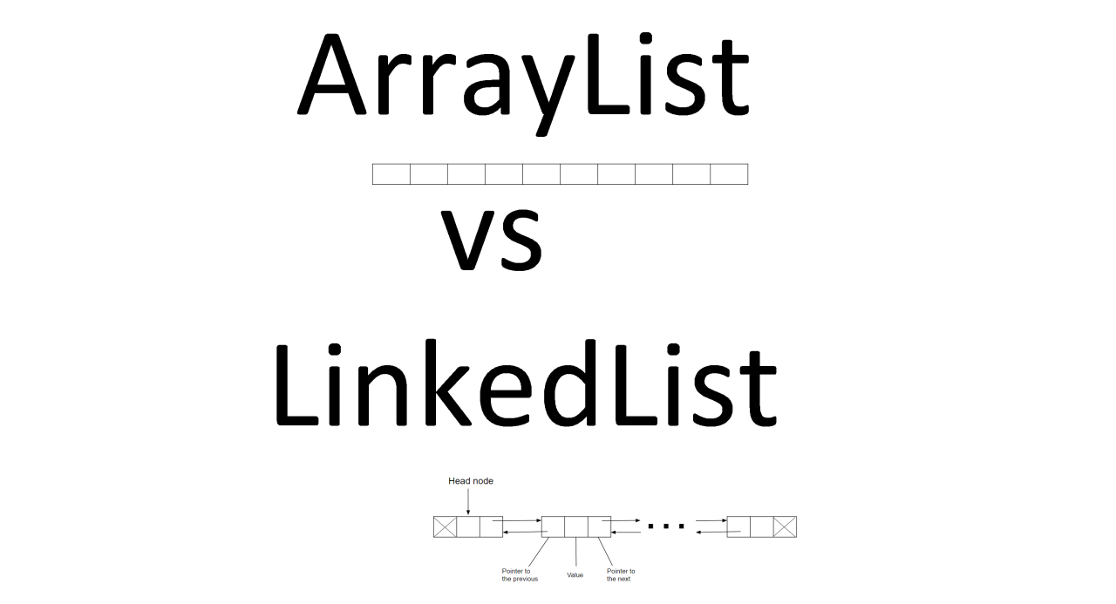

1. What is a List (Definition)
- A List is an ordered collection
- Maintains insertion order
- Allows duplicate elements
- Allows index-based access
- Part of java.util package

2. Types of List in Java (BIG PICTURE)
Non-Concurrent Lists
- ArrayList
- LinkedList
- Vector (thread-safe but NOT concurrent)
- Collections.synchronizedList(...) (thread-safe but NOT concurrent)
Concurrent List
- CopyOnWriteArrayList (ONLY ONE)

3. Non-Concurrent List (Meaning)
Definition
- A non-concurrent list is NOT safe when accessed by multiple threads at the same time
- No internal synchronization
- Designed mainly for single-threaded usage

4. Types of Non-Concurrent List
ArrayList
- Dynamic array
- Fast random access
- Slow insert/delete in middle
- Not thread-safe
LinkedList
- Doubly linked list
- Fast insert/delete
- Slow random access
- Not thread-safe
Vector
- Thread-safe using synchronized
- Uses single lock
- Very slow
- Legacy class
Collections.synchronizedList
List<Integer> list =
Collections.synchronizedList(new ArrayList<>());
- Thread-safe
- Uses single lock
- Not scalable

5. Limitations of Non-Concurrent List (VERY IMPORTANT)
- Race conditions
- Data inconsistency
- ConcurrentModificationException
- Manual synchronization required
- Poor performance if synchronized externally
📌 Interview line
Non-concurrent lists fail in multi-threaded environments due to lack of internal synchronization.

6. Real-Time Problem with Non-Concurrent List
Scenario
Multiple threads update a shared list (unsafe)
Example (ArrayList – WITHOUT concurrency)
import java.util.*;

public class NonConcurrentListProblem {
public static void main(String[] args) throws Exception {
List<Integer> list = new ArrayList<>();

Runnable task = () -> {
for (int i = 0; i < 1000; i++) {
list.add(i);
}
};

Thread t1 = new Thread(task);
Thread t2 = new Thread(task);

t1.start();
t2.start();
t1.join();
t2.join();

// Expected: 2000, Actual: unpredictable
System.out.println("Final size: " + list.size());
}
}
What Happens Step-by-Step
- Two threads access same ArrayList
- Internal array updates overlap
- Elements are overwritten or lost
- Final size becomes incorrect

7. What is a Concurrent List
Definition
- A concurrent list is designed to work safely in multi-threaded environments
- Provides thread safety + scalability
- No global locking
Java Provides ONLY ONE
CopyOnWriteArrayList

8. Why Only One Concurrent List Exists
- Lists are index-based
- High write concurrency causes heavy shifting
- Copy-on-write is optimal only for read-heavy scenarios
- Other designs would be slower than synchronized lists

9. CopyOnWriteArrayList (Concurrent List)
How It Works (Step-by-Step)
- Read operations → no lock
- Write operation → creates a new copy of array
- Iterator works on snapshot
- No ConcurrentModificationException

10. Real-Time Use Case of Concurrent List
- Application configuration
- Feature flags
- Observer / listener list
- Cache metadata

11. Real-Time Example – WITH Concurrent List
import java.util.concurrent.*;

public class ConcurrentListExample {
public static void main(String[] args) {

CopyOnWriteArrayList<String> list =
new CopyOnWriteArrayList<>();

list.add("CONFIG_1");
list.add("CONFIG_2");

for (String value : list) {
list.add("NEW_CONFIG");
System.out.println(value);
}

System.out.println("Final List: " + list);
}
}
What Happens Step-by-Step
- Loop starts on snapshot
- New element added to new copy
- Iterator continues safely
- No exception
- Thread-safe execution

12. Comparison: Non-Concurrent vs Concurrent List
Aspect | Non-Concurrent List | Concurrent List
Thread Safety | No | Yes
Concurrent Read | No | Yes
Concurrent Write | No | Expensive
Iteration Safety | No | Yes
Best Use | Single thread | Read-heavy multi-thread

13. When NOT to Use CopyOnWriteArrayList
- Write-heavy applications
- Large lists with frequent updates
- Real-time low-latency writes
Copying entire array is expensive

14. Interview-Ready One-Line Summary
ArrayList and LinkedList are non-concurrent and unsafe for multi-threading, while Java provides only one concurrent List—CopyOnWriteArrayList—which uses copy-on-write strategy and is best suited for read-heavy concurrent applications.

SET IN JAVA – TYPES, NON-CONCURRENT vs CONCURRENT (DEEP, STEP-BY-STEP WITH REAL-TIME EXAMPLES)

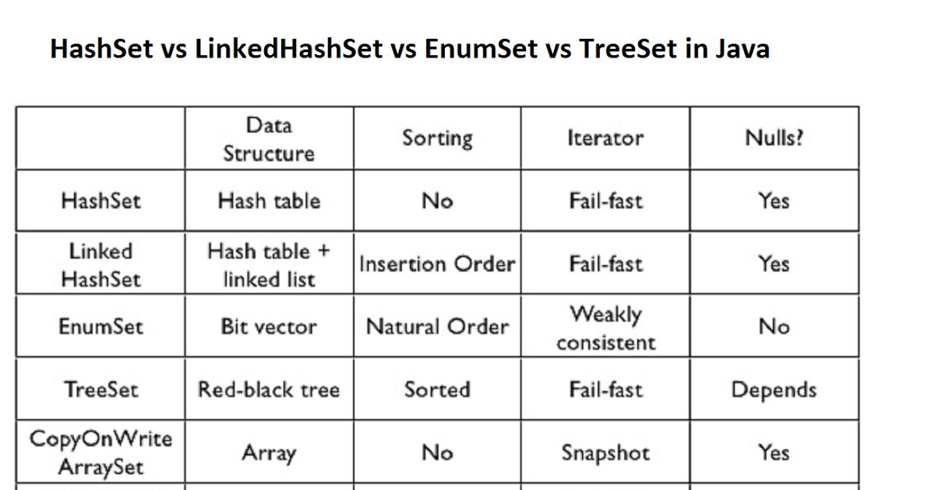
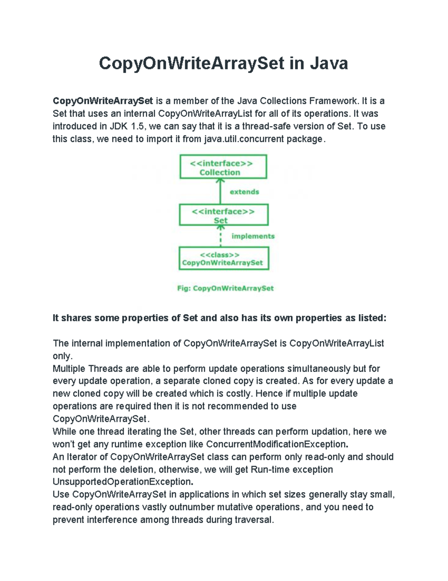

1. What is a Set (Definition)
- A Set is a collection that does NOT allow duplicate elements
- Order depends on implementation
- No index-based access
- Used when uniqueness is required
- Part of java.util package

2. Types of Set in Java (BIG PICTURE)
Non-Concurrent Sets
- HashSet
- LinkedHashSet
- TreeSet
- Collections.synchronizedSet(...) (thread-safe but NOT concurrent)
Concurrent Sets
- CopyOnWriteArraySet
- ConcurrentSkipListSet

3. Non-Concurrent Set (Meaning)
Definition
- A non-concurrent Set is NOT safe when accessed by multiple threads
- No internal synchronization
- Concurrent access can cause data inconsistency or runtime exceptions

4. Types of Non-Concurrent Set
HashSet
- No order guaranteed
- Fast add/remove/contains
- Internally uses HashMap
- Not thread-safe
LinkedHashSet
- Maintains insertion order
- Slightly slower than HashSet
- Not thread-safe
TreeSet
- Maintains sorted order
- Uses Red-Black Tree
- Slower operations (O(log n))
- Not thread-safe
Synchronized Set
Set<Integer> set =
Collections.synchronizedSet(new HashSet<>());
- Thread-safe
- Uses single lock
- Poor scalability

5. Limitations of Non-Concurrent Set (IMPORTANT)
- Race conditions
- Duplicate entries may appear logically
- ConcurrentModificationException
- Manual synchronization required
- Poor performance under concurrency
📌 Interview line
Non-concurrent Sets are unsafe in multi-threaded environments due to lack of internal synchronization.

6. Real-Time Problem with Non-Concurrent Set
Scenario
Multiple threads register users into a shared Set (unsafe).
Example – WITHOUT Concurrency (HashSet)
import java.util.*;

public class NonConcurrentSetProblem {
public static void main(String[] args) throws Exception {
Set<Integer> users = new HashSet<>();

Runnable task = () -> {
for (int i = 0; i < 1000; i++) {
users.add(i);
}
};

Thread t1 = new Thread(task);
Thread t2 = new Thread(task);

t1.start();
t2.start();
t1.join();
t2.join();

System.out.println("Total users: " + users.size());
}
}
What Happens Step-by-Step
- Two threads modify HashSet simultaneously
- Internal HashMap buckets are updated concurrently
- Data corruption or inconsistent size possible

7. What is a Concurrent Set
Definition
- A concurrent Set is designed to work safely in multi-threaded environments
- Provides thread safety without global locking
- Supports safe iteration

8. Types of Concurrent Set in Java
CopyOnWriteArraySet
- Backed by CopyOnWriteArrayList
- Best for read-heavy workloads
ConcurrentSkipListSet
- Sorted concurrent Set
- Skip-list based
- Better for ordered concurrent data

9. CopyOnWriteArraySet (Concurrent Set – Read Heavy)
How It Works (Step-by-Step)
- Read operations → no lock
- Write operations → create a new copy
- Iterators work on snapshot
- No ConcurrentModificationException

Real-Time Use Case
- Event listeners
- Subscribers list
- Feature toggles

Example – WITH Concurrency (CopyOnWriteArraySet)
import java.util.concurrent.*;
public class CopyOnWriteArraySetExample {
public static void main(String[] args) {
CopyOnWriteArraySet<String> listeners =
new CopyOnWriteArraySet<>();
listeners.add("ListenerA");
listeners.add("ListenerB");
for (String l : listeners) {
listeners.add("ListenerC");
System.out.println(l);
}
System.out.println("Final Set: " + listeners);
}
}
What Happens Step-by-Step
- Iteration uses snapshot
- New element added safely
- No exception
- Thread-safe execution

10. ConcurrentSkipListSet (Concurrent Sorted Set)
Definition
- Thread-safe and sorted
- Uses Skip-List (not tree)
- Supports high concurrency

Real-Time Use Case
- Leaderboards
- Ranking systems
- Sorted unique IDs

Example – WITH Concurrency (ConcurrentSkipListSet)
import java.util.concurrent.*;
public class ConcurrentSkipListSetExample {
public static void main(String[] args) {
ConcurrentSkipListSet<Integer> ranks =
new ConcurrentSkipListSet<>();
ranks.add(3);
ranks.add(1);
ranks.add(2);
System.out.println("Ranks: " + ranks);
}
}

11. Comparison: Non-Concurrent vs Concurrent Set
Aspect | Non-Concurrent Set | Concurrent Set
Thread Safety | No | Yes
Iteration Safety | No | Yes
Sorting Support | TreeSet only | ConcurrentSkipListSet
Best Use | Single thread | Multi-threaded
Performance | High (single) | High (multi)

12. When NOT to Use CopyOnWriteArraySet
- Write-heavy systems
- Large Sets with frequent updates
- Low-latency write requirements

13. Interview-Ready One-Line Summary
HashSet, LinkedHashSet, and TreeSet are non-concurrent and unsafe for multi-threading, while CopyOnWriteArraySet and ConcurrentSkipListSet provide thread-safe Set implementations for read-heavy and sorted concurrent use cases respectively.

MAP IN JAVA – TYPES, NON-CONCURRENT vs CONCURRENT (DEEP, STEP-BY-STEP WITH REAL-TIME EXAMPLES)



1. What is a Map (Definition)
- A Map stores data as key–value pairs
- Keys are unique, values can be duplicated
- No index-based access
- Retrieval is based on key lookup
- Part of java.util package
- Map does not extend Collection

2. Types of Map in Java (BIG PICTURE)
Non-Concurrent Maps
- HashMap
- LinkedHashMap
- TreeMap
- Collections.synchronizedMap(...) (thread-safe but NOT concurrent)
- Hashtable (legacy, thread-safe but NOT concurrent)
Concurrent Maps
- ConcurrentHashMap
- ConcurrentSkipListMap (sorted concurrent map)

3. Non-Concurrent Map (Meaning)
Definition
- A non-concurrent Map is NOT safe when accessed by multiple threads
- No internal concurrency control
- Designed mainly for single-threaded or externally synchronized use

4. Types of Non-Concurrent Map
HashMap
- Fastest general-purpose Map
- No ordering guarantee
- Allows one null key and multiple null values
- Not thread-safe
LinkedHashMap
- Maintains insertion order
- Slightly slower than HashMap
- Not thread-safe
TreeMap
- Maintains sorted order of keys
- Uses Red-Black Tree
- Slower operations (O(log n))
- Not thread-safe
Synchronized Map
Map<Integer, String> map =
Collections.synchronizedMap(new HashMap<>());
- Thread-safe
- Uses single global lock
- Poor scalability

5. Limitations of Non-Concurrent Map (IMPORTANT)
- Race conditions
- Lost updates
- Data inconsistency
- ConcurrentModificationException during iteration
- Poor performance if manually synchronized
📌 Interview line
Non-concurrent Maps are unsafe in multi-threaded environments due to lack of internal concurrency control.

6. Real-Time Problem with Non-Concurrent Map
Scenario
Multiple threads update a shared user-session Map (unsafe).
Example – WITHOUT Concurrency (HashMap)
import java.util.*;

public class NonConcurrentMapProblem {
public static void main(String[] args) throws Exception {
Map<Integer, Integer> sessions = new HashMap<>();

Runnable task = () -> {
for (int i = 0; i < 1000; i++) {
sessions.put(i, i);
}
};

Thread t1 = new Thread(task);
Thread t2 = new Thread(task);

t1.start();
t2.start();
t1.join();
t2.join();

System.out.println("Total sessions: " + sessions.size());
}
}
What Happens Step-by-Step
- Two threads modify the same HashMap
- Internal bucket updates overlap
- Entries may be lost or overwritten
- Final size becomes unpredictable

7. What is a Concurrent Map
Definition
- A concurrent Map is designed to work safely and efficiently in multi-threaded environments
- Allows simultaneous reads and writes
- Avoids global locking

8. ConcurrentHashMap (Primary Concurrent Map)
How It Works (Step-by-Step)
- No global lock on entire map
- Java 8+ uses bucket-level locking + CAS
- Multiple threads update different buckets simultaneously
- Iterators are fail-safe
- Does not allow null key or value

9. Real-Time Use Case of ConcurrentHashMap
- User session management
- Application caches
- Shared counters
- Rate limiting data

10. Real-Time Example – WITH Concurrent Map
import java.util.concurrent.*;

public class ConcurrentMapExample {
public static void main(String[] args) throws Exception {

ConcurrentHashMap<Integer, Integer> sessions =
new ConcurrentHashMap<>();

Runnable task = () -> {
for (int i = 0; i < 1000; i++) {
sessions.put(i, i);
}
};

Thread t1 = new Thread(task);
Thread t2 = new Thread(task);

t1.start();
t2.start();
t1.join();
t2.join();

System.out.println("Total sessions: " + sessions.size());
}
}
What Happens Step-by-Step
- Threads update different buckets
- No data loss
- High throughput
- Safe for production systems

11. ConcurrentNavigableMap → ConcurrentSkipListMap
Definition
- Thread-safe sorted Map
- Based on skip-list data structure
- Maintains natural or custom key order

Real-Time Use Case
- Leaderboards
- Time-based sorted data
- Ranked reports

Example – WITH Concurrent Sorted Map
import java.util.concurrent.*;

public class ConcurrentSkipListMapExample {
public static void main(String[] args) {

ConcurrentSkipListMap<Integer, String> leaderboard =
new ConcurrentSkipListMap<>();

leaderboard.put(3, "UserC");
leaderboard.put(1, "UserA");
leaderboard.put(2, "UserB");

System.out.println("Leaderboard: " + leaderboard);
}
}

12. Comparison: Non-Concurrent vs Concurrent Map
Aspect | Non-Concurrent Map | Concurrent Map
Thread Safety | No | Yes
Locking | None / Global | Fine-grained
Iteration Safety | No | Yes
Null Keys | Allowed | No
Best Use | Single thread | Multi-threaded

13. When NOT to Use ConcurrentHashMap
- Single-threaded programs
- Very small Maps
- When ordering is mandatory (use ConcurrentSkipListMap instead)

14. Interview-Ready One-Line Summary
HashMap, LinkedHashMap, and TreeMap are non-concurrent and unsafe for multi-threading, while ConcurrentHashMap and ConcurrentSkipListMap provide scalable, thread-safe Map implementations for real-time concurrent applications.

QUEUE IN JAVA – TYPES, NON-CONCURRENT vs CONCURRENT (DEEP, STEP-BY-STEP WITH REAL-TIME EXAMPLES)
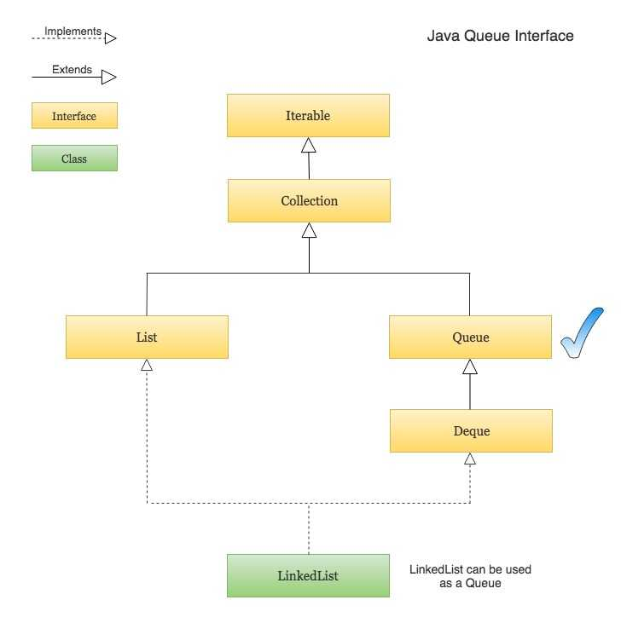
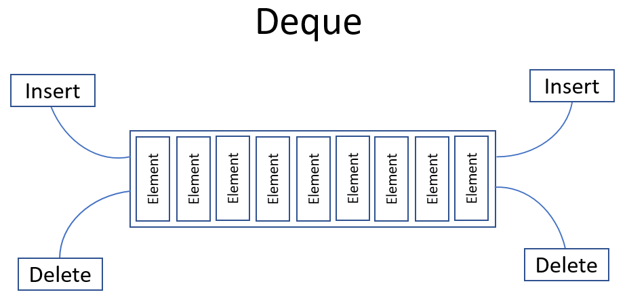
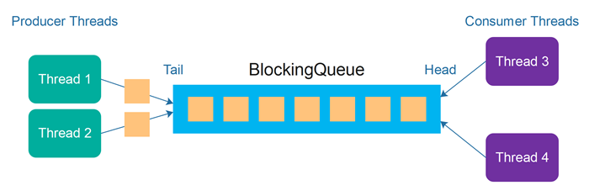
5

1. What is a Queue (Definition)
- A Queue is a collection used for ordered processing of elements
- Generally follows FIFO (First In, First Out)
- Elements are added at the tail and removed from the head
- No index-based access
- Part of java.util and java.util.concurrent

2. Why Queue Is Used (Real-Time Meaning)
- Task scheduling
- Request handling
- Producer–consumer systems
- Messaging and event processing

3. Types of Queue in Java (BIG PICTURE)
Non-Concurrent Queues
- LinkedList
- ArrayDeque
- PriorityQueue
Concurrent Non-Blocking Queues
- ConcurrentLinkedQueue
- ConcurrentLinkedDeque
Concurrent Blocking Queues
- ArrayBlockingQueue
- LinkedBlockingQueue
- PriorityBlockingQueue
- DelayQueue
- SynchronousQueue

4. Non-Concurrent Queue (Meaning)
Definition
- Not safe for multi-threaded access
- No internal synchronization
- External synchronization required

5. Non-Concurrent Queue Classes
LinkedList (as Queue)
- Doubly linked list
- Allows null
- FIFO behavior
Example – WITHOUT Concurrency
import java.util.*;

public class LinkedListQueueExample {
public static void main(String[] args) {
Queue<String> queue = new LinkedList<>();

queue.offer("Task1");
queue.offer("Task2");

System.out.println(queue.poll());
System.out.println(queue);
}
}
Meaning
- Works in single-threaded environment
- Unsafe for multiple producers/consumers

ArrayDeque
- Array-based queue
- Faster than LinkedList
- Does not allow null
Example – WITHOUT Concurrency
import java.util.*;

public class ArrayDequeQueueExample {
public static void main(String[] args) {
Queue<Integer> queue = new ArrayDeque<>();

queue.offer(1);
queue.offer(2);

System.out.println(queue.poll());
}
}
Meaning
- Best non-concurrent queue
- Unsafe in multi-threading

PriorityQueue
- Orders elements by priority, not FIFO
- Uses heap internally
Example – WITHOUT Concurrency
import java.util.*;

public class PriorityQueueExample {
public static void main(String[] args) {
Queue<Integer> queue = new PriorityQueue<>();
queue.offer(30);
queue.offer(10);
queue.offer(20);
System.out.println(queue.poll());
}
}
Meaning
- Used for priority-based processing
- Not thread-safe

6. Limitations of Non-Concurrent Queues
- Race conditions
- Data inconsistency
- No automatic blocking
- Manual synchronization needed
Interview line
Non-concurrent queues are unsafe in producer–consumer systems.

7. Concurrent Non-Blocking Queues
ConcurrentLinkedQueue
Definition
- Thread-safe FIFO queue
- Non-blocking
- Lock-free algorithm
Real-Time Use Case
- Asynchronous event processing
- Logging systems

ConcurrentLinkedQueue vs Non-Concurrent Queue (Step-by-Step with Real-Time Example)
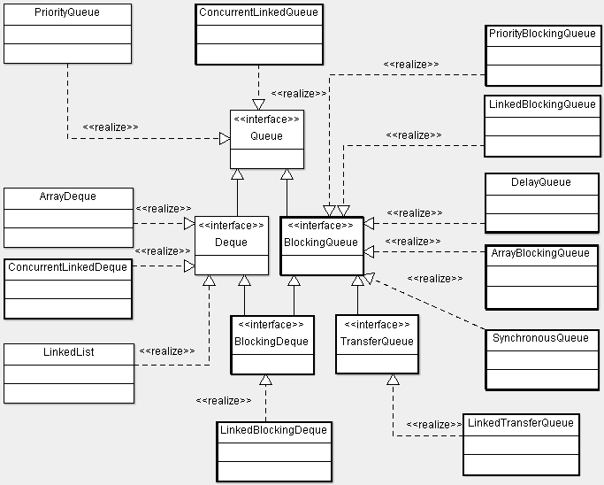



1️⃣What is a Non-Concurrent Queue
Definition
- A queue not designed for multi-threaded access
- No internal synchronization
- Multiple threads can corrupt data
Common Non-Concurrent Queues
- LinkedList
- ArrayDeque
- PriorityQueue

What is ConcurrentLinkedQueue
Definition
- A thread-safe, non-blocking, lock-free FIFO queue
- Multiple threads can add/remove at the same time
- Uses CAS (Compare-And-Swap) internally

Real-Time Scenario (Same for Both)
Scenario: Event Processing System
- Many threads generate events (producers)
- Many threads process events (consumers)
- Order matters (FIFO)
- High throughput required

NON-CONCURRENT QUEUE (LinkedList) – PROBLEM
Code Example (Without Concurrency)
import java.util.*;

public class NonConcurrentQueueDemo {

static Queue<String> queue = new LinkedList<>();

public static void main(String[] args) {

Runnable producer = () -> {
for (int i = 1; i <= 5; i++) {
String event = Thread.currentThread().getName() + "-E" + i;
queue.offer(event);
System.out.println("Produced: " + event);
}
};

Runnable consumer = () -> {
while (!queue.isEmpty()) {
String event = queue.poll();
System.out.println("Consumed: " + event);
}
};

new Thread(producer, "Producer-1").start();
new Thread(producer, "Producer-2").start();
new Thread(consumer, "Consumer-1").start();
}
}

Step-by-Step What Goes Wrong
- Producer-1 and Producer-2 modify LinkedList together
- Internal pointers (first, last) update simultaneously
- Consumer reads while producers are writing
- Possible results:
  - Missing elements
  - NullPointerException
  - Corrupted internal structure
  - Unpredictable output
Key Problem
LinkedList is NOT thread-safe

ConcurrentLinkedQueue vs Non-Concurrent Queue (Clear, Step-by-Step Comparison)

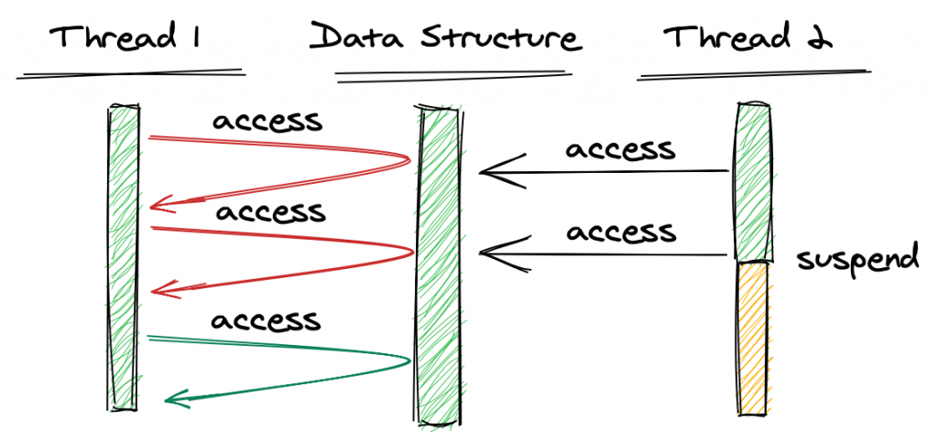


1️⃣ What is a Non-Concurrent Queue
Definition
- A queue not designed for multi-threaded access
- No internal synchronization
- Multiple threads accessing it at the same time can corrupt data
Common Non-Concurrent Queues
- LinkedList
- ArrayDeque
- PriorityQueue

2️⃣ What is ConcurrentLinkedQueue
Definition
- A thread-safe, non-blocking, lock-free FIFO queue
- Multiple threads can add and remove simultaneously
- Uses CAS (Compare-And-Swap) internally

3️⃣ Real-Time Scenario (Same for Both)
Scenario: Event Processing System
- Multiple producer threads generate events
- Multiple consumer threads process events
- FIFO order is required
- High throughput is important

4️⃣ Non-Concurrent Queue Example (LinkedList – Problem)
import java.util.*;

public class NonConcurrentQueueDemo {

static Queue<String> queue = new LinkedList<>();

public static void main(String[] args) {

Runnable producer = () -> {
for (int i = 1; i <= 5; i++) {
String event = Thread.currentThread().getName() + "-E" + i;
queue.offer(event);
System.out.println("Produced: " + event);
}
};

Runnable consumer = () -> {
while (!queue.isEmpty()) {
String event = queue.poll();
System.out.println("Consumed: " + event);
}
};

new Thread(producer, "Producer-1").start();
new Thread(producer, "Producer-2").start();
new Thread(consumer, "Consumer-1").start();
}
}
Step-by-Step What Goes Wrong
- Two producers modify LinkedList at the same time
- Internal pointers (first, last) update concurrently
- Consumer reads while producers are writing
- Results may include:
  - Missing elements
  - NullPointerException
  - Corrupted queue structure
  - Unpredictable output
❌ LinkedList is NOT thread-safe

5️⃣ ConcurrentLinkedQueue Example (Solution)
import java.util.Queue;
import java.util.concurrent.ConcurrentLinkedQueue;

public class ConcurrentQueueDemo {

static Queue<String> queue = new ConcurrentLinkedQueue<>();

public static void main(String[] args) {

Runnable producer = () -> {
for (int i = 1; i <= 5; i++) {
String event = Thread.currentThread().getName() + "-E" + i;
queue.offer(event);
System.out.println("Produced: " + event);
}
};

Runnable consumer = () -> {
String event;
while ((event = queue.poll()) != null) {
System.out.println("Consumed: " + event);
}
};

new Thread(producer, "Producer-1").start();
new Thread(producer, "Producer-2").start();
new Thread(consumer, "Consumer-1").start();
}
}
Step-by-Step What Happens Correctly
- Producers call offer()
  - CAS safely updates the tail
- Consumer calls poll()
  - CAS safely updates the head
- If queue is empty → poll() returns null
- No locking, no waiting, no corruption
✔ Thread-safe
✔ Non-blocking
✔ High throughput

6️⃣ Key Differences (One-Look Table)
Feature | Non-Concurrent Queue | ConcurrentLinkedQueue
Thread safety | ❌ No | ✅ Yes
Locking | ❌ None | ❌ None (CAS)
Blocking | ❌ No | ❌ No
Multi-thread use | ❌ Unsafe | ✅ Safe
Performance (concurrent) | ❌ Poor | ✅ High
Empty queue behavior | N/A | poll() returns null

When to Use Which
Use Non-Concurrent Queue
- Single-threaded programs
- No shared access
- Simple logic
Use ConcurrentLinkedQueue
- Multiple producers & consumers
- Event systems
- Logging pipelines
- Async / reactive systems
- Low-latency, high-throughput applications

8️⃣ Interview-Ready One-Line Answer
Non-concurrent queues like LinkedList are unsafe in multi-threaded environments, while ConcurrentLinkedQueue is a lock-free, non-blocking, thread-safe FIFO queue designed for high-throughput concurrent systems.

When to Use Which
Use LinkedList / ArrayDeque
- Single-threaded programs
- No shared access
Use ConcurrentLinkedQueue
- Multiple producers & consumers
- Event systems
- Logging pipelines
- Async processing
- Low-latency systems

Interview-Ready One-Line Answer
LinkedList is not thread-safe and fails in multi-threaded queue scenarios, while ConcurrentLinkedQueue is a lock-free, non-blocking, thread-safe FIFO queue designed for high-throughput concurrent systems.

ConcurrentLinkedDeque – Complete Explanation with Meaningful Multi-Threaded Example

1. What is ConcurrentLinkedDeque (Definition)
- ConcurrentLinkedDeque is a thread-safe, non-blocking, lock-free double-ended queue (Deque)
- Allows insertion and removal from both ends (head and tail)
- Multiple threads can operate simultaneously
- Uses CAS (Compare-And-Swap) instead of locks
- Part of java.util.concurrent
In simple words:
A high-performance concurrent deque where threads never wait.

2. Why ConcurrentLinkedDeque Is Needed
Problems with non-concurrent Deque
- ArrayDeque, LinkedList
- Not thread-safe
- Data corruption in multi-threading
Problems with blocking Deque
- LinkedBlockingDeque
- Thread-safe but threads block
- Slower under heavy load
What ConcurrentLinkedDeque Provides
- Thread safety
- No blocking
- Very high throughput

3. Real-Time Use Case
Work-Stealing Task Scheduler
- Each worker thread adds tasks to one end
- Idle threads steal tasks from the other end
- No locking
- No waiting
Used in:
- Parallel execution engines
- Fork/Join frameworks
- Asynchronous task processing

4. Key Operations
- addFirst() → add at front
- addLast() → add at end
- pollFirst() → remove from front
- pollLast() → remove from end

5. Non-Concurrent Deque Example (Problem)
import java.util.*;

public class NonConcurrentDequeDemo {
static Deque<Integer> deque = new ArrayDeque<>();

public static void main(String[] args) {
Runnable task = () -> {
for (int i = 0; i < 5; i++) {
deque.addLast(i); // NOT thread-safe
}
};

new Thread(task).start();
new Thread(task).start();
}
}
What Goes Wrong
- Two threads modify ArrayDeque simultaneously
- Internal array pointers collide
- Data corruption or exception possible

6. ConcurrentLinkedDeque – Multi-Threaded Example
Scenario
- Multiple producers add tasks
- Multiple consumers process tasks
- Tasks can be taken from either end

Complete Working Example
import java.util.Deque;
import java.util.concurrent.ConcurrentLinkedDeque;

public class ConcurrentLinkedDequeDemo {

static Deque<String> deque = new ConcurrentLinkedDeque<>();

public static void main(String[] args) {

// Producer: add tasks at the end
Runnable producer = () -> {
String name = Thread.currentThread().getName();
for (int i = 1; i <= 5; i++) {
String task = name + "-Task-" + i;
deque.addLast(task);
System.out.println("Produced: " + task);
}
};

// Consumer: steal tasks from the front
Runnable consumer = () -> {
String name = Thread.currentThread().getName();
String task;
while ((task = deque.pollFirst()) != null) {
System.out.println(name + " processed: " + task);
}
};

Thread p1 = new Thread(producer, "Producer-1");
Thread p2 = new Thread(producer, "Producer-2");

Thread c1 = new Thread(consumer, "Consumer-1");
Thread c2 = new Thread(consumer, "Consumer-2");

p1.start();
p2.start();

try { Thread.sleep(100); } catch (InterruptedException e) {}

c1.start();
c2.start();
}
}

7. Step-by-Step What Happens
Producer Threads
- Call addLast()
- CAS updates tail pointer
- No lock, no waiting
Consumer Threads
- Call pollFirst()
- CAS updates head pointer
- If empty → returns null
Result
- No blocking
- No data loss
- Safe concurrent execution

8. Key Characteristics (Interview Ready)
- Thread-safe
- Lock-free
- Non-blocking
- Supports both ends
- Weakly consistent iterators
- Returns null when empty

9. ConcurrentLinkedDeque vs LinkedBlockingDeque
Feature | ConcurrentLinkedDeque | LinkedBlockingDeque
Thread safety | ✅ | ✅
Blocking | ❌ No | ✅ Yes
Locks | ❌ CAS | ✅ Locks
Throughput | Very high | Moderate
Use case | Async / work-stealing | Producer–consumer

10. When to Use ConcurrentLinkedDeque
Use it when:
- You want maximum concurrency
- Threads must never block
- Work-stealing pattern is needed
- Low-latency systems
Do NOT use it when:
- Capacity control is required
- Threads must wait
→ Use LinkedBlockingDeque

11. Interview One-Line Answer
ConcurrentLinkedDeque is a lock-free, non-blocking, thread-safe double-ended queue designed for high-throughput concurrent systems such as work-stealing and asynchronous task processing.

8. Concurrent Blocking Queues (MOST IMPORTANT)
BlockingQueue – Definition
- Thread-safe queue
- Blocks producer when full
- Blocks consumer when empty
- Designed for producer–consumer pattern

ArrayBlockingQueue – Complete Explanation with Real-Time Multi-Threaded Example
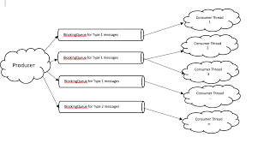

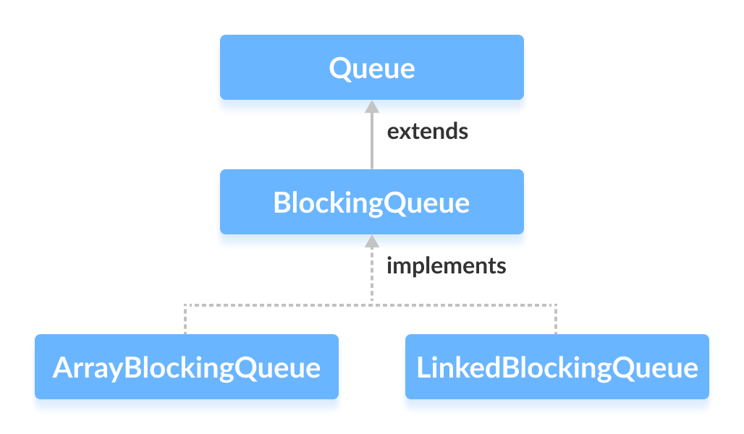

1. What is ArrayBlockingQueue (Definition)
- ArrayBlockingQueue is a thread-safe, bounded, blocking queue
- Backed by a fixed-size array
- Implements FIFO (First-In, First-Out)
- Part of java.util.concurrent
- Uses locks + conditions internally
In simple words:
A fixed-capacity queue where producers wait when full and consumers wait when empty.

2. Why ArrayBlockingQueue Is Needed
Problems with non-concurrent queues
- LinkedList, ArrayDeque
- Not thread-safe
- No waiting mechanism
- Producer–consumer logic becomes complex
What ArrayBlockingQueue Provides
- Built-in thread safety
- Automatic blocking
- Capacity control
- Clean producer–consumer design

3. Key Characteristics
- Fixed size (capacity must be defined)
- Thread-safe
- Blocking operations
- Predictable memory usage
- Optional fairness policy
new ArrayBlockingQueue<>(capacity, true); // fair ordering

4. Common Methods (Meaning)
- put(e) → waits if queue is full
- take() → waits if queue is empty
- offer(e) → returns false if full
- poll() → returns null if empty
- peek() → views head without removing

5. Real-Time Use Case
Producer–Consumer System
- Producers generate jobs
- Consumers process jobs
- Queue size must be limited to avoid memory overflow
Used in:
- Thread pools
- Job scheduling systems
- Message processing pipelines

6. Non-Concurrent Queue Example (Problem)
import java.util.*;

public class NonConcurrentQueueProblem {
static Queue<Integer> queue = new LinkedList<>();

public static void main(String[] args) {
new Thread(() -> queue.add(1)).start();
new Thread(() -> queue.remove()).start();
}
}
What Goes Wrong
- No blocking
- No thread safety
- Race conditions possible

7. ArrayBlockingQueue – Real-Time Multi-Threaded Example
Scenario
- Producer adds tasks
- Consumer processes tasks
- Queue capacity = 2
- Producer must wait when queue is full

Complete Working Example
import java.util.concurrent.ArrayBlockingQueue;
import java.util.concurrent.BlockingQueue;

public class ArrayBlockingQueueDemo {

static BlockingQueue<Integer> queue =
new ArrayBlockingQueue<>(2);

public static void main(String[] args) {

// Producer thread
Runnable producer = () -> {
try {
for (int i = 1; i <= 5; i++) {
System.out.println("Producing: " + i);
queue.put(i); // blocks if queue is full
Thread.sleep(500);
}
} catch (InterruptedException e) {
Thread.currentThread().interrupt();
}
};

// Consumer thread
Runnable consumer = () -> {
try {
while (true) {
Integer value = queue.take(); // blocks if empty
System.out.println("Consuming: " + value);
Thread.sleep(1000);
}
} catch (InterruptedException e) {
Thread.currentThread().interrupt();
}
};

new Thread(producer, "Producer").start();
new Thread(consumer, "Consumer").start();
}
}

8. Step-by-Step What Happens
- Producer calls put(1)
  - Queue empty → element added
- Producer calls put(2)
  - Queue now full
- Producer calls put(3)
  - Queue full → producer blocks
- Consumer calls take()
  - Removes element
  - Producer unblocks automatically
- Process continues smoothly
✔ No busy-waiting
✔ No data loss
✔ Clean synchronization

9. ArrayBlockingQueue vs ConcurrentLinkedQueue
Feature | ArrayBlockingQueue | ConcurrentLinkedQueue
Thread-safe | ✅ | ✅
Blocking | ✅ | ❌
Capacity | Fixed | Unbounded
Locks | Yes | No (CAS)
Use case | Producer–consumer | Async event systems

10. When to Use ArrayBlockingQueue
Use it when:
- You need capacity control
- Producer must wait
- Consumer must wait
- Predictable memory usage required
Do NOT use when:
- High-throughput async systems
- No blocking allowed
→ Use ConcurrentLinkedQueue

11. Interview-Ready One-Line Answer
ArrayBlockingQueue is a bounded, thread-safe, blocking FIFO queue used in producer–consumer systems where capacity control and automatic thread coordination are required.

LinkedBlockingQueue
- Optional size
- Higher throughput
BlockingQueue<Integer> queue =
new LinkedBlockingQueue<>();
Use Case
- Thread pools
- Message queues
LinkedBlockingQueue – Complete Explanation with Real-Time Multi-Threaded Example
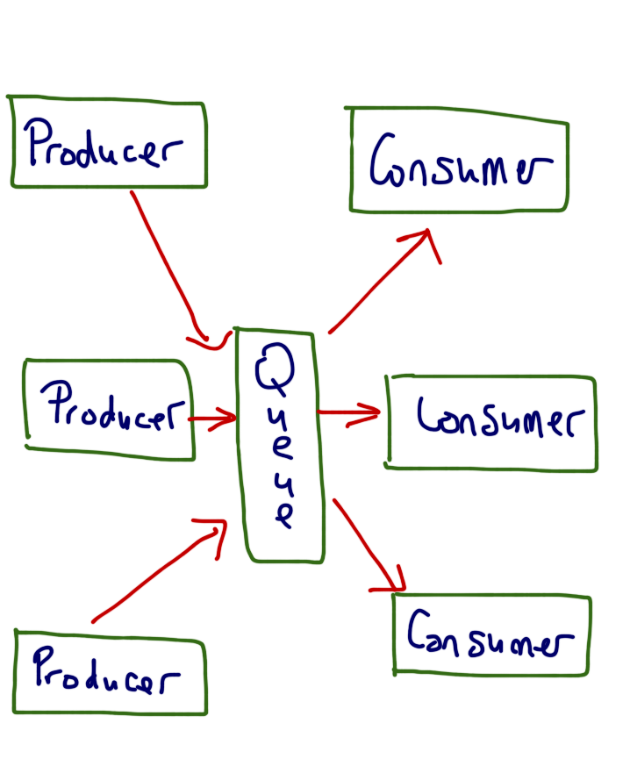

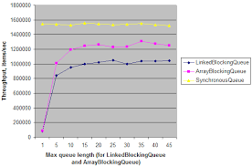

1. What is LinkedBlockingQueue (Definition)
- LinkedBlockingQueue is a thread-safe, blocking queue
- Backed by a linked list
- Follows FIFO (First-In, First-Out)
- Part of java.util.concurrent
- Uses separate locks for put and take operations
In simple words:
A scalable blocking queue where producers wait when full and consumers wait when empty, with better throughput than array-based queues.

2. Why LinkedBlockingQueue Is Needed
Problems with Non-Concurrent Queues
- LinkedList, ArrayDeque
- Not thread-safe
- No blocking → complex producer–consumer logic
Limitations of ArrayBlockingQueue
- Fixed size only
- Single lock → lower concurrency
What LinkedBlockingQueue Solves
- Optional capacity (bounded or unbounded)
- Better concurrency using two locks
- Ideal for high-throughput producer–consumer systems

3. Key Characteristics
- Thread-safe
- FIFO order
- Blocking behavior
- Optional capacity
- Higher throughput than ArrayBlockingQueue
new LinkedBlockingQueue<>(); // unbounded
new LinkedBlockingQueue<>(100); // bounded

4. Important Methods (Meaning)
- put(e) → waits if queue is full
- take() → waits if queue is empty
- offer(e) → returns false if full
- poll() → returns null if empty
- peek() → reads head without removing

5. Real-Time Use Cases
- Thread pools (ExecutorService)
- Job scheduling systems
- Message processing pipelines
- Web server request queues

6. Non-Concurrent Queue Example (Problem)
import java.util.*;

public class NonConcurrentQueueProblem {
static Queue<Integer> queue = new LinkedList<>();

public static void main(String[] args) {
new Thread(() -> queue.add(1)).start();
new Thread(() -> queue.remove()).start();
}
}
What Goes Wrong
- No thread safety
- No blocking
- Race conditions possible

7. LinkedBlockingQueue – Real-Time Multi-Threaded Example
Scenario
- Multiple producers generate jobs
- Multiple consumers process jobs
- Queue capacity = 3
- Producers must wait if queue is full

Complete Working Example
import java.util.concurrent.BlockingQueue;
import java.util.concurrent.LinkedBlockingQueue;

public class LinkedBlockingQueueDemo {

static BlockingQueue<Integer> queue =
new LinkedBlockingQueue<>(3);

public static void main(String[] args) {

// Producer
Runnable producer = () -> {
try {
for (int i = 1; i <= 6; i++) {
System.out.println("Producing: " + i);
queue.put(i); // blocks if full
Thread.sleep(400);
}
} catch (InterruptedException e) {
Thread.currentThread().interrupt();
}
};

// Consumer
Runnable consumer = () -> {
try {
while (true) {
Integer value = queue.take(); // blocks if empty
System.out.println("Consuming: " + value);
Thread.sleep(1000);
}
} catch (InterruptedException e) {
Thread.currentThread().interrupt();
}
};

new Thread(producer, "Producer-1").start();
new Thread(producer, "Producer-2").start();
new Thread(consumer, "Consumer-1").start();
}
}

8. Step-by-Step What Happens
- Producer adds elements using put()
- When queue reaches capacity → producer blocks
- Consumer calls take()
- Consumer removes element
- Producer automatically resumes
- Process continues smoothly
✔ No busy-waiting
✔ No manual synchronization
✔ Safe and scalable

9. LinkedBlockingQueue vs ArrayBlockingQueue
Feature | LinkedBlockingQueue | ArrayBlockingQueue
Internal structure | Linked list | Array
Capacity | Optional | Fixed
Locks | Two (put/take) | One
Throughput | Higher | Lower
Memory | More | Less
Use case | High concurrency | Predictable size

10. When to Use LinkedBlockingQueue
Use it when:
- High producer–consumer throughput is needed
- Queue size may grow dynamically
- Used with thread pools and executors
Do NOT use it when:
- Memory usage must be strictly bounded
- Very small queues are required
→ Use ArrayBlockingQueue

11. Interview-Ready One-Line Answer
LinkedBlockingQueue is a thread-safe, FIFO, blocking queue backed by a linked list, offering higher concurrency than ArrayBlockingQueue and widely used in producer–consumer systems and thread pools.

PriorityBlockingQueue – Complete Explanation with Real-Time Multi-Threaded Example
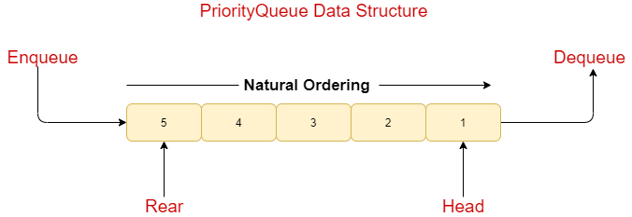
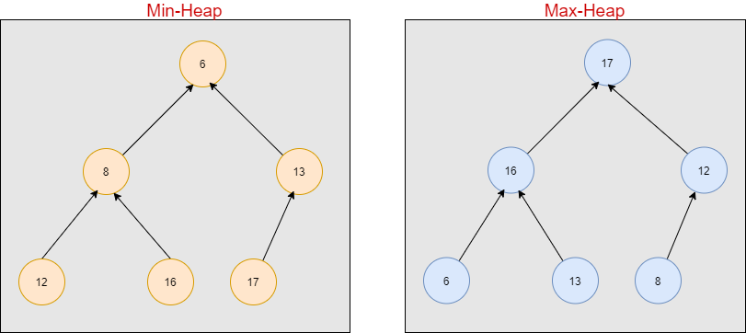
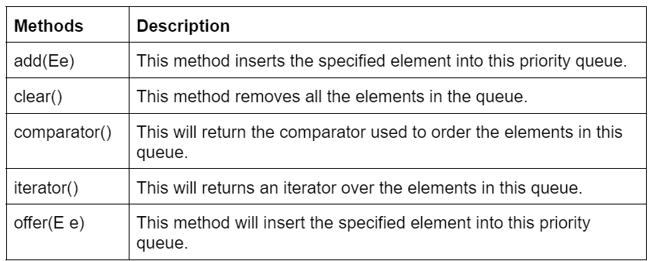

1. What is PriorityBlockingQueue (Definition)
- PriorityBlockingQueue is a thread-safe, blocking queue
- Elements are ordered by priority, not FIFO
- Based on a heap (priority queue)
- Part of java.util.concurrent
- Unbounded queue (no fixed capacity)
In simple words:
A blocking queue where the highest-priority element is always processed first.

2. Why PriorityBlockingQueue Is Needed
Problems with Normal PriorityQueue
- PriorityQueue is not thread-safe
- No blocking support
- Unsafe in multi-threaded environments
What PriorityBlockingQueue Solves
- Thread safety
- Blocking behavior for consumers
- Priority-based task processing

3. Key Characteristics
- Thread-safe
- Priority-based ordering
- Blocking on take()
- Does not block on put() (unbounded)
- Does not allow null elements

4. How Priority Is Decided
- Natural ordering (Comparable)
- Custom ordering (Comparator)
new PriorityBlockingQueue<>();
new PriorityBlockingQueue<>(11, comparator);

5. Real-Time Use Cases
- Task scheduling systems
- Job processing with priority
- Operating system–like schedulers
- Message queues with urgency levels

6. Non-Concurrent PriorityQueue Example (Problem)
import java.util.*;

public class PriorityQueueProblem {
static Queue<Integer> queue = new PriorityQueue<>();

public static void main(String[] args) {
new Thread(() -> queue.add(10)).start();
new Thread(() -> queue.add(5)).start();
new Thread(() -> System.out.println(queue.poll())).start();
}
}
What Goes Wrong
- Not thread-safe
- Race conditions
- Data corruption possible

7. PriorityBlockingQueue – Real-Time Multi-Threaded Example
Scenario
- Tasks have different priorities
- Consumers must always process highest-priority task first
- Consumers wait when queue is empty

Complete Working Example
import java.util.concurrent.BlockingQueue;
import java.util.concurrent.PriorityBlockingQueue;

public class PriorityBlockingQueueDemo {

static BlockingQueue<Integer> queue =
new PriorityBlockingQueue<>();

public static void main(String[] args) {

// Producer
Runnable producer = () -> {
try {
queue.put(30);
System.out.println("Produced: 30");
queue.put(10);
System.out.println("Produced: 10");
queue.put(20);
System.out.println("Produced: 20");
} catch (InterruptedException e) {
Thread.currentThread().interrupt();
}
};

// Consumer
Runnable consumer = () -> {
try {
while (true) {
Integer value = queue.take(); // blocks if empty
System.out.println("Consumed: " + value);
}
} catch (InterruptedException e) {
Thread.currentThread().interrupt();
}
};

new Thread(producer, "Producer").start();
new Thread(consumer, "Consumer").start();
}
}

8. Step-by-Step What Happens
- Producer inserts 30, 10, 20
- Queue internally arranges them as [10, 20, 30]
- Consumer calls take()
- Consumer always gets smallest (highest priority) element
- If queue is empty → consumer blocks
✔ Priority respected
✔ Thread-safe
✔ Clean synchronization

9. PriorityBlockingQueue with Custom Objects (Real-World Example)
Task Class
class Task implements Comparable<Task> {
int priority;
String name;

Task(int priority, String name) {
this.priority = priority;
this.name = name;
}

@Override
public int compareTo(Task o) {
return Integer.compare(this.priority, o.priority);
}
}
Using PriorityBlockingQueue
import java.util.concurrent.*;

public class TaskScheduler {
public static void main(String[] args) throws Exception {

BlockingQueue<Task> queue =
new PriorityBlockingQueue<>();

queue.put(new Task(1, "High"));
queue.put(new Task(3, "Low"));
queue.put(new Task(2, "Medium"));

while (!queue.isEmpty()) {
System.out.println(queue.take().name);
}
}
}
Output
High
Medium
Low

10. PriorityBlockingQueue vs ArrayBlockingQueue
Feature | PriorityBlockingQueue | ArrayBlockingQueue
Ordering | Priority-based | FIFO
Capacity | Unbounded | Fixed
Blocking on put | ❌ No | ✅ Yes
Blocking on take | ✅ Yes | ✅ Yes
Use case | Priority tasks | Producer–consumer

11. Important Limitations
- Unbounded → risk of memory growth
- No fairness guarantee
- Ordering is not stable for equal priorities

12. When to Use PriorityBlockingQueue
Use it when:
- Tasks must be processed by priority
- Consumers should wait when empty
- Scheduling logic is required
Do NOT use when:
- Capacity control is required
- Strict FIFO ordering is needed
→ Use ArrayBlockingQueue or LinkedBlockingQueue

13. Interview-Ready One-Line Answer
PriorityBlockingQueue is a thread-safe, unbounded blocking queue that processes elements based on priority rather than FIFO order, making it ideal for priority-based task scheduling systems.

DelayQueue
- Elements available after delay
- Uses Delayed interface
Use Case
- Session timeout
- Scheduled tasks
BlockingQueue<Delayed> queue =
new DelayQueue<>();
DelayQueue – Complete Explanation with Real-Time Multi-Threaded Example
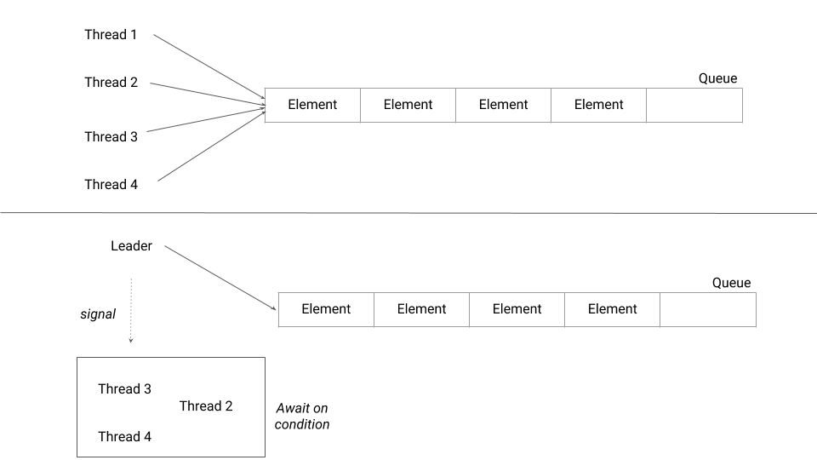

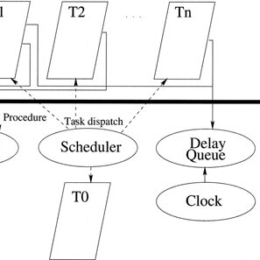

1. What is DelayQueue (Definition)
- DelayQueue is a thread-safe, blocking queue
- Elements become available only after a given delay expires
- Works with elements implementing the Delayed interface
- Part of java.util.concurrent
- Queue is unbounded
In simple words:
A queue where items can be taken only after their delay time is over.

2. Why DelayQueue Is Needed
Problems with Normal Queues
- LinkedBlockingQueue, ArrayBlockingQueue
- FIFO only
- No time-based execution
- Manual scheduling required
What DelayQueue Solves
- Built-in time-based scheduling
- Automatic waiting until delay expires
- Thread-safe and clean design

3. Key Characteristics
- Thread-safe
- Time-based ordering (earliest delay first)
- Blocking on take()
- No blocking on put() (unbounded)
- Does not allow null
- Internally uses a priority queue

4. Where DelayQueue Is Used (Real-Time Use Cases)
- Session timeout handling
- Cache expiration
- Retry mechanisms
- Scheduled background tasks
- Token expiration (OTP, password reset)

5. How DelayQueue Works (Step-by-Step)
- Producer inserts an element with delay
- Queue sorts elements by delay time
- Consumer calls take()
- If delay not expired → consumer blocks
- Once delay expires → element becomes available

6. Non-Concurrent Alternative (Problem)
Queue<String> queue = new LinkedList<>();
Problem
- No time control
- Manual sleep() required
- Not scalable
- Error-prone in multi-threading

7. DelayQueue – Real-Time Multi-Threaded Example
Scenario
- OTP expires after 5 seconds
- Expired OTPs must be processed automatically

Step 1: Create Delayed Object
import java.util.concurrent.Delayed;
import java.util.concurrent.TimeUnit;

class OTP implements Delayed {

private final String code;
private final long expireTime;

OTP(String code, long delaySeconds) {
this.code = code;
this.expireTime =
System.currentTimeMillis() +
TimeUnit.SECONDS.toMillis(delaySeconds);
}

@Override
public long getDelay(TimeUnit unit) {
long diff = expireTime - System.currentTimeMillis();
return unit.convert(diff, TimeUnit.MILLISECONDS);
}

@Override
public int compareTo(Delayed o) {
return Long.compare(this.expireTime,
((OTP) o).expireTime);
}

public String getCode() {
return code;
}
}

Step 2: Use DelayQueue with Producer & Consumer
import java.util.concurrent.DelayQueue;

public class DelayQueueDemo {

static DelayQueue<OTP> queue = new DelayQueue<>();

public static void main(String[] args) {

// Producer: add OTPs
new Thread(() -> {
System.out.println("OTP 123 added (5 sec)");
queue.put(new OTP("123", 5));

System.out.println("OTP 456 added (10 sec)");
queue.put(new OTP("456", 10));
}).start();

// Consumer: process expired OTPs
new Thread(() -> {
try {
while (true) {
OTP otp = queue.take(); // blocks until delay expires
System.out.println("Expired OTP: " + otp.getCode());
}
} catch (InterruptedException e) {
Thread.currentThread().interrupt();
}
}).start();
}
}

8. Sample Output (Time-Based)
OTP 123 added (5 sec)
OTP 456 added (10 sec)
(5 seconds later)
Expired OTP: 123
(5 seconds later)
Expired OTP: 456
✔ Automatic scheduling
✔ No manual sleep
✔ Thread-safe

9. DelayQueue vs ScheduledExecutorService
Feature | DelayQueue | ScheduledExecutorService
Time-based | ✅ | ✅
Task execution | ❌ | ✅
Storage | Queue | Thread pool
Use case | Expiry handling | Task execution

10. Important Limitations
- Unbounded → memory risk
- Only works with Delayed elements
- Not FIFO (time-based ordering)

11. When to Use DelayQueue
Use it when:
- You need time-based availability
- Expiry or timeout logic is required
- You want clean producer–consumer scheduling
Do NOT use it when:
- You need fixed-delay repeated tasks
→ Use ScheduledExecutorService

12. Interview-Ready One-Line Answer
DelayQueue is a thread-safe blocking queue where elements become available only after their delay expires, commonly used for expiration, timeout, and scheduling-related tasks.

SynchronousQueue – Complete Explanation with Real-Time Multi-Threaded Example

1. What is SynchronousQueue (Definition)
- SynchronousQueue is a thread-safe, blocking queue
- Capacity = 0 (stores no elements)
- Every put() must wait for a take()
- Every take() must wait for a put()
- Part of java.util.concurrent
In simple words:
A handoff queue where a producer gives data directly to a consumer.

2. Why SynchronousQueue Is Needed
Problems with Normal / Blocking Queues
- They store elements
- Memory grows with load
- Producers may outrun consumers
What SynchronousQueue Solves
- No storage → no memory growth
- Forces direct coordination
- Ideal for thread handoff

3. Key Characteristics
- Thread-safe
- Zero capacity
- Strict handoff
- Blocking on both put() and take()
- Optional fairness mode
new SynchronousQueue<>(); // non-fair
new SynchronousQueue<>(true); // fair (FIFO)

4. Real-Time Use Cases
- Thread pools (Executors.newCachedThreadPool)
- Task handoff between threads
- Load balancing systems
- Producer must wait for consumer readiness

5. Important Methods (Meaning)
- put(e) → waits until another thread calls take()
- take() → waits until another thread calls put(e)
- offer(e) → returns false if no consumer waiting
- poll() → returns null if no producer waiting

6. Non-Concurrent Alternative (Problem)
Queue<Integer> queue = new LinkedList<>();
Problem
- Stores data
- No direct synchronization
- Unsafe and uncontrolled in concurrency

7. SynchronousQueue – Real-Time Multi-Threaded Example
Scenario
- Producer generates tasks
- Consumer must be ready before task is handed off
- No buffering allowed

Complete Working Example
import java.util.concurrent.BlockingQueue;
import java.util.concurrent.SynchronousQueue;

public class SynchronousQueueDemo {

static BlockingQueue<String> queue =
new SynchronousQueue<>();

public static void main(String[] args) {

// Consumer
new Thread(() -> {
try {
System.out.println("Consumer waiting...");
String data = queue.take(); // waits
System.out.println("Consumer received: " + data);
} catch (InterruptedException e) {
Thread.currentThread().interrupt();
}
}).start();

// Producer
new Thread(() -> {
try {
Thread.sleep(2000);
System.out.println("Producer producing...");
queue.put("Task-1"); // waits until consumer is ready
System.out.println("Producer completed handoff");
} catch (Exception e) {
Thread.currentThread().interrupt();
}
}).start();
}
}

8. Step-by-Step What Happens
- Consumer calls take()
→ blocks (no producer yet)
- Producer calls put("Task-1")
→ finds waiting consumer
- Direct handoff occurs
→ no storage, no queueing
- Both threads continue execution
✔ No buffering
✔ No memory usage
✔ Perfect synchronization

9. Sample Output
Consumer waiting...
Producer producing...
Consumer received: Task-1
Producer completed handoff

10. SynchronousQueue vs Other BlockingQueues
Feature | SynchronousQueue | ArrayBlockingQueue | LinkedBlockingQueue
Capacity | 0 | Fixed | Optional
Storage | ❌ None | ✅ Yes | ✅ Yes
Blocking | Both sides | When full/empty | When full/empty
Use case | Direct handoff | Bounded buffer | High throughput

11. When to Use SynchronousQueue
Use it when:
- You want direct producer → consumer handoff
- No buffering is allowed
- Tasks must be processed immediately
- Thread pools scale dynamically
Do NOT use it when:
- Tasks must be queued
- Buffering is required
→ Use ArrayBlockingQueue or LinkedBlockingQueue

12. Real-World Example (Very Important)
Executors.newCachedThreadPool();
Internally uses:
SynchronousQueue
Meaning:
- New thread created if no idle thread available
- No task queueing
- Maximum responsiveness

13. Interview-Ready One-Line Answer
SynchronousQueue is a zero-capacity blocking queue that enables direct handoff between producer and consumer threads, commonly used in thread pools and high-performance handoff scenarios.

10. Comparison Table (ONE LOOK)
Type | Class | Blocking | Thread-Safe
Queue | LinkedList | No | No
Queue | ArrayDeque | No | No
Queue | PriorityQueue | No | No
Queue | ConcurrentLinkedQueue | No | Yes
Deque | ConcurrentLinkedDeque | No | Yes
BlockingQueue | ArrayBlockingQueue | Yes | Yes
BlockingQueue | LinkedBlockingQueue | Yes | Yes
BlockingQueue | PriorityBlockingQueue | Yes | Yes
BlockingQueue | DelayQueue | Yes | Yes
BlockingQueue | SynchronousQueue | Yes | Yes

11. Interview-Ready One-Line Summary
Queues in Java range from simple non-concurrent FIFO structures to advanced concurrent and blocking queues that support high-performance, thread-safe producer–consumer systems used in real-world applications.

